Introduction to NFS and autofs

|  |
| --- |
| In this document, **Server** always refers to the class server **htc180** and **Client** refers to any of the other machines in the room, i.e., **Clients** are **htc181** through **htc200**.  **All commands in this document are issued on the NFS Client** |

**Network File System** (**NFS**) is a **distributed file system** protocol originally developed by **Sun Microsystems** in 1984, allowing a user on a clientcomputer to access files over a computer network much like local storage is accessed. **NFS** is still widely supported and used on **Linux** machines today.

The diagram below, although complicated looking, shows a **Client** **Computer** using the **NFS** protocol to access the **Unix file system** on the **Server Computer**. From the command line both systems (**Client and Server**) will see the identical files and file system.

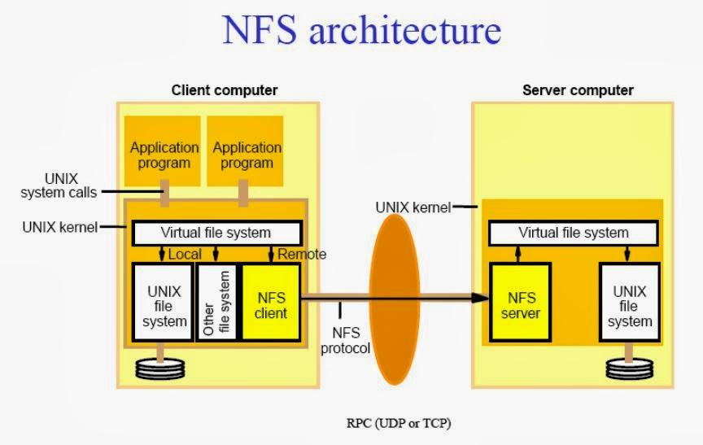

**Exporting a File System:**

In order for a **Client** to **NFS** mount a **Server’s** file system, the **Server** must “**export**” the **file system** to the **Client**. The Server’s **export configuration** file is:

|  |
| --- |
| /etc/exports |

with content similar to:

|  |
| --- |
| /nfs/htc180 htc181(rw,async,root_squash) \  htc182(rw,async,root_squash) \  …  htc200(rw,async,root_squash) |

The field on the left is the **file system** that the **server** is “**exporting**” and the list on the right are the **hosts** that can “**mount**” the file system. The values in **()** are options for the **exported** file system. In this case:

* **rw** - Allow **Clients** to **read** and **write** to the file system
* **async** - **Buffer** the **output**. This means the client stores updates to the server’s file system in memory and then periodically writes sends them to the server. This results in a large performance improvement over **sync** or **non-buffered** output.
* **root_squash** - **Do not allow** the client to access the file system with **root privileges**. This is a security feature.

NFS Mounting a File System:

Before a Client can use NFS mount, we must install the nfs-tools package:

|  |
| --- |
| yum -y install nfs-utils |

Now a **Client** can **NFS** **mount** a **Server’s** file system using the **mount** command:

|  |
| --- |
| mkdir -p /nfs/htc180  mount htc180:/nfs/htc180 /nfs/htc180 |

In this example, both the **Client** and the **Server** will see the identical file system under /nfs/htc180. Try looking at the files mounted from the server:

|  |
| --- |
| ls -al /nfs/htc180/ |

Automatically mounting a file system:

When we have many **NFS** file systems on many different servers, we do not want to have them all mounted all the time. The software system **autofs** will control **automatically** **mounting** and **unmounting** file systems when the **Client** tries to access them.

Begin by unmounting the file system from the previous section:

|  |
| --- |
| umount /nfs/htc180 |

|  |
| --- |
| NOTE: The command is **umount** not **unmount**. It is not u**n**mount. |

Check that the file system is really unmounted. The following should return any output:

|  |
| --- |
| df | grep htc180 |

|  |
| --- |
| **df - report file system disk space usage**  df displays the amount of disk space available on the file system containing each file name argument. If no file name is given, the space available on all currently mounted file systems is shown. |

Now install the **autofs package**:

|  |
| --- |
| yum -y install autofs |

Configure autofs on the Client. There are two files that we need to change:

* /etc/auto.master - The main configuration for autofs
* /etc/auto.nfs - The configuration file specific to file systems under /nfs.

Modify **/etc/auto.master.** Open the file in an editor and comment all the lines. Then add the following line at the bottom of the file:

|  |
| --- |
| /nfs /etc/auto.nfs |

Now create the file /etc/auto.nfs with the single line:

|  |
| --- |
| htc180 htc180:/nfs/htc180 |

The line in **/etc/auto.master** tells autofs to monitor the directory **/nfs** and tryto **auto-mount** file systems listed in **/etc/auto.nfs** The single line in **auto.nfs** means:

* Parameter 1 (htc180) - If **/nfs/htc180** is accessed
* Parameter 2 (htc180:) - Contact the host **htc180**
* Parameter 3 (/nfs/htc180) - Mount **/nfs/htc180**

Start and enable the autofs service:

|  |
| --- |
| systemctl start autofs  systemctl enable autofs |

Now test:

|  |
| --- |
| cd /nfs/htc180  ls -al |

|  |
| --- |
| **Now instead of using curl to access files on the class server, you can read them directly.** |